# 1) Story:

Everytime Internet doesn’t work, most of users blame sharks for biting a sea cable. So in this game, we’re going to control the submarine to prevent sharks from biting cable.

# 2) Characters:

- **The sea cable:**

+ Properties: HP

+ Behavior: Bitten(), LoadSkin(), IncreaseHP().

**- Sharks:**

+ Properties: Size, Color, Damage, Speed.

+ Behavior: Killed(), Damage(), Angry(), RunAway(), ChangeDirection(), DoClone()

**- Bubble:**

+ Properties: Position, Color, Speed.

+ Behavior: Move()

**- Special Bubble (Bomb/Grid):**

+ Properties: Damage, Range, Countdown.

+ Behavior: Damage(), Skill(), RandomKind()

**- The submarine:**

+ Properties: ListBubble, Power.

+ Behavior: Shoot(), Move().

**- Items:**

+ Properties: Kind (Stun, IncreaseHP, Bomb), Score.

+ Behavior: Skill().

**- Sea creatures:**

+ Properties: Kind (SOctopus, NormalFish).

+ Behavior: Move(), Killed(), Skill().

# 3) Level:

- **Level 1:** Shark which has one color will appear.

- **Level 2:** Shark which has one and two color will appear and the two-colored shark only appear in last stage.

- **Level 3:** Shark which has from one to three color will appear and the three-colored shark only appear in last stage.

- **Level 4:** Color-scheme shark will appear.

- **Level 5:** Random sharks.

# 4) Gameplay:

The cable is laid between screen and the submarine is going to move up and down automatically on the cable. Sharks and other creatures such as normal fishes or octopuses are going to move from two sides of screen. One map lasts in 45 seconds and is divided into three stages. Player must wait for the submarine and press right button – which has color that duplicate with sharks’ color. Due to several kinds of sharks, players must press one or many times buttons to kill sharks before they meet the cable. If a shark still alive, it will bite the cable and die. Player will lose when HP of the cable is 0. Of course, player will win when pass 3 stages with HP of the cable is more than 0.

# 5) Flow Chart:

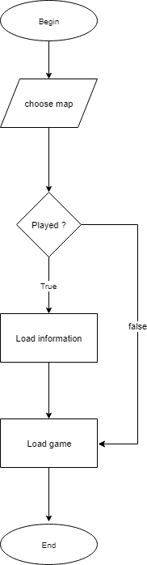

image 1: Choose map activity

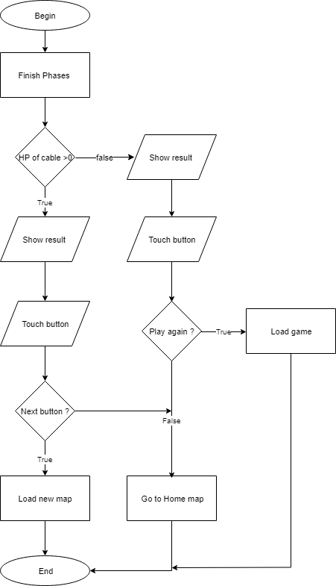

Image 2: Win-Lose activity

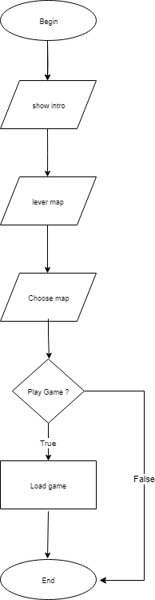

Image 3: Game activity

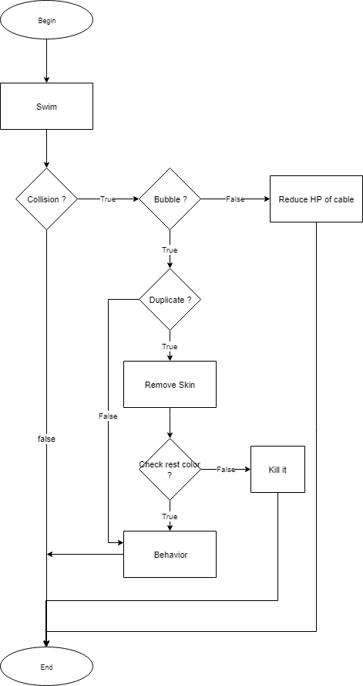

Image 4: Collision activity

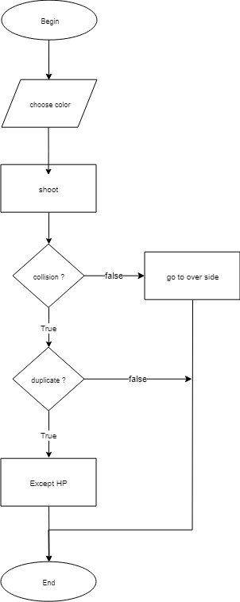

Image 5: Shoot activity

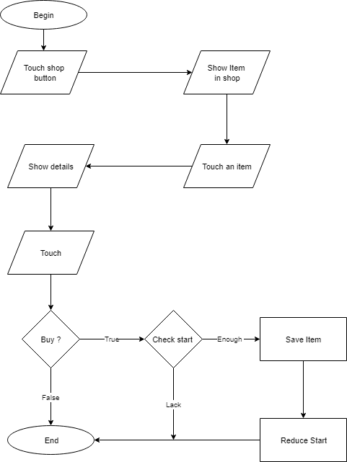

Hình 6: Shopping activity

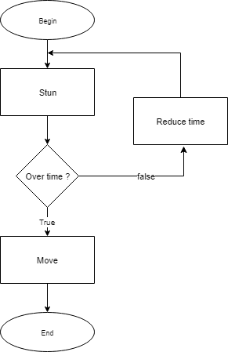

Hình 7: Stun activity

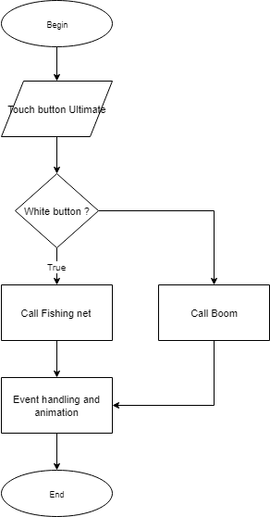

Hình 8: ultimate activity

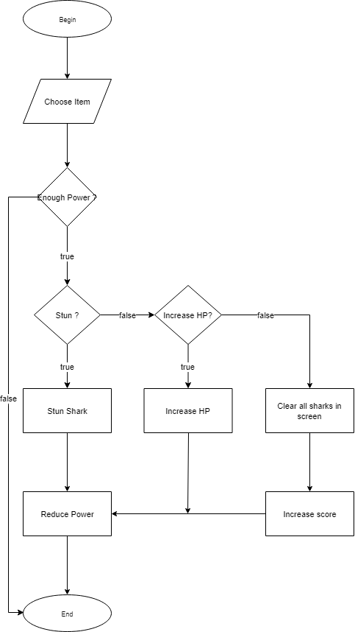

Hình 9: choose item in game activity

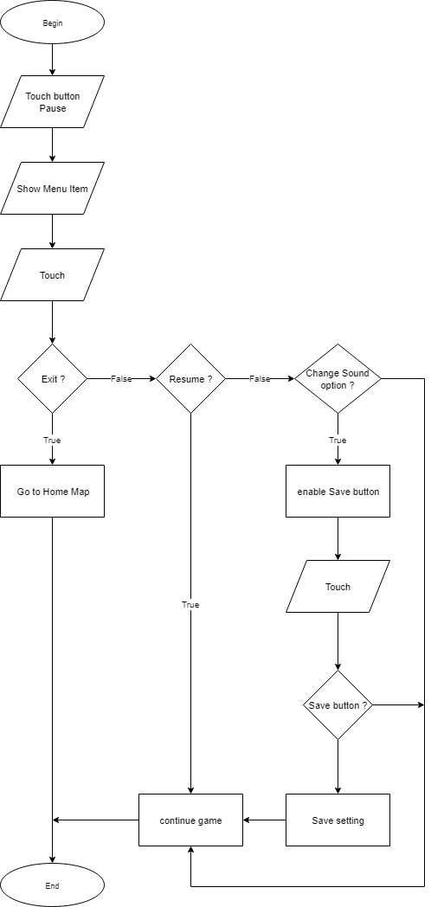

Image 10: Pause activity

# 6) Sound and music:

# 7) User Interface, Game control: